http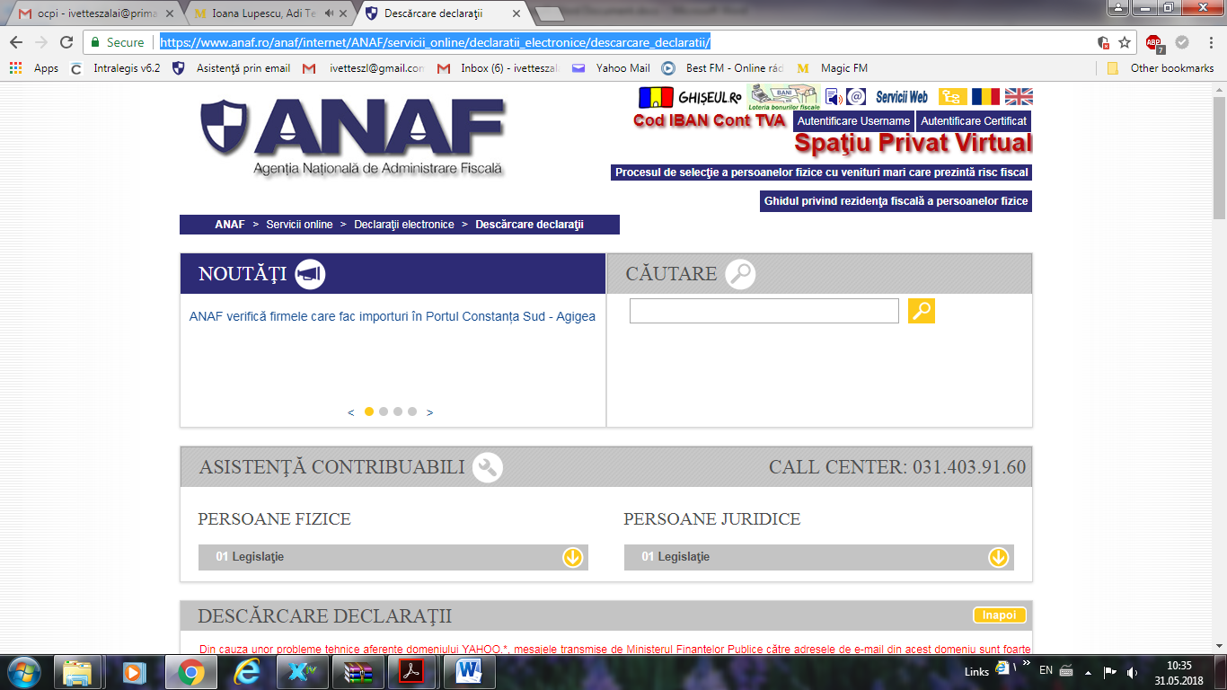s://www.anaf.ro/anaf/internet/ANAF/servicii_online/declaratii_electronice/descarcare_declaratii/

